1. **GTasks: To Do List & Task List**

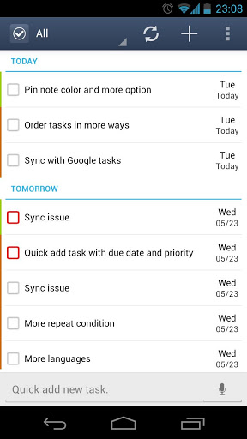

GTasks is a simple and efficient task management app with both local and google account mode. You can customize your to do list, set reminder, share tasks with your friends, family members or colleagues and sync with your google tasks perfectly

**Features:**

- Rich gtask (google task) client, simple todo list, checklist, note/notes pad tool.  
- Synchronize with multiple google accounts automatically,

- Order your tasks easily by dragging them

- Repeat reminder enable, set reminder one-time/daily/weekly/monthly...

- Quick add task by pressing the search key

- Quick search task with autocomplete  
- Widgets on Android home screen

1. **Trello - Organize Anything**

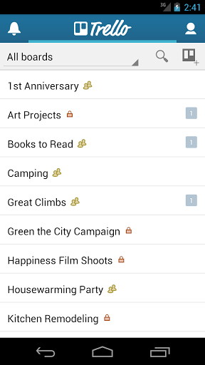

Trello is simple to use and infinitely flexible. And, everything you do is synced and saved instantly to Trello.com.

With Trello, you can create boards to organize anything you're working on. Use them solo, or invite friends, family, or colleagues to work together.

Write your ideas down on Trello cards and arrange them in lists on your boards. Add details to your cards such as:  
- checklists to keep track of to-dos  
- comments to update your co-workers  
- photos and videos  
- who's working on that card

1. **2Do: To do List | Task List**

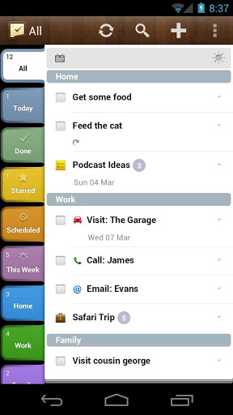 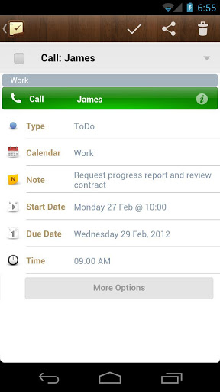

From a simple checklist to full-blown project management, 2Do is an incredibly powerful, award winning, task manager that lets you focus on what's important

**Features:**

Projects, Checklists or a simple To do list

Repeating tasks with end dates

Tabbed Lists for easy organization and grouping

Landscape Calendar view with date markers and date-filtering

Password Protection: Lock all your tasks or individually picked Lists

Drag & Drop tasks from and to Lists

 Easy sorting by dates, lists, priority, status, title or manual sorting

Alarms: Easily create multiple alarms per task

Attach Photos to your tasks using the Camera or the Gallery

Backup & Restore: Create easy backups of your database or restore from an existing one at any time